Eleanor Romany, author of the Enchanted Mountains Series
About the author
Eleanor Romany (pen name) is the author of the Enchanted Mountains Series. The romance novels are inspired by Allegany State Park in Western New York, the place where she, her husband, and his family vacation each summer. It’s also the place where her husband asked her to marry him during a hike, and she said yes.
Eleanor lives in Lexington, Kentucky, and grew up in Ashland, Kentucky. Her other hobbies include reading, checking out new restaurants, traveling, and daydreaming about her next fictional love story.
About the series
The Enchanted Mountains Series is a collection of stand-alone novels set in the scenic beauty of fictional Twin Pines State Park. While the heart of the series is the beauty of nature, the true stories are found within the characters. The series follows the lives of the people who come to the park all year long seeking peace, adventure, or escape and those who make up the Twin Pines community looking for the same things.

FEATURED TITLES

Longing for More (book 1)
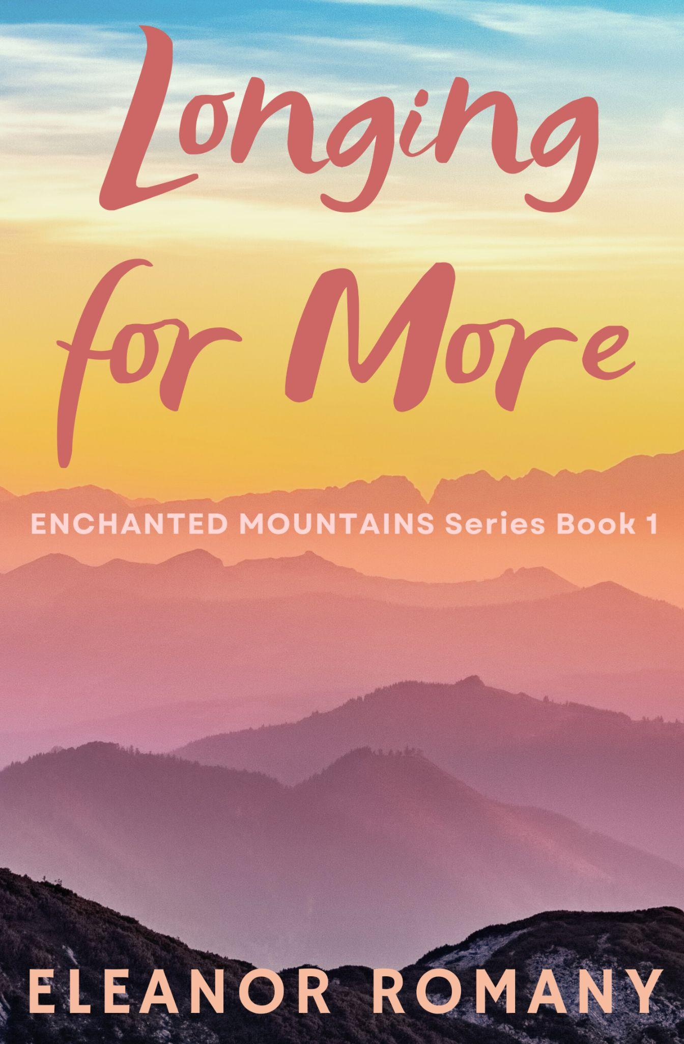
Rating: Amazon 4.6; Goodreads 4.5
Genre: Contemporary romance
Themes: small-town; summer; nature and outdoors; workplace; vacation; low spice
Format: Paperback
ISBN: 9798999679673
Price: $7.99
Page Count: 124
Publisher: Independently Published
Released: July 2025
Book Description:
Mariah Rivera has spent most of her life near the park: walking its wooded trails, swimming in the sparkling lake, and knowing deep in her heart that this is where she belongs. But lately, even with a job at the lodge she loves and surrounded by all the beauty and peace she’s always loved, something still feels like it’s missing.
Luke Anderson never planned on coming back. His career and his jet-setting lifestyle are a far cry from who he used to be. But when life in the city falls apart, the treasured place of his childhood calls. Can a week at Twin Pines change anything?
Their first encounter at the lodge sends a shock of something unfamiliar straight through both of them. In this tender and heartfelt first installment of the Enchanted Mountains series, two souls—one rooted and one restless—collide in a place where the stars shine brighter, the air feels lighter, and hearts can finally find what they were missing.
Perfect For Readers Who Enjoy:
• Instant attraction; falling fast; misunderstandings; feel-good reads
Available Through:
IngramSpark; direct from author
Wholesale Terms via IngramSpark:
• Discount: 40%
• Returns: Yes

That First Summer: Part One (book 2)
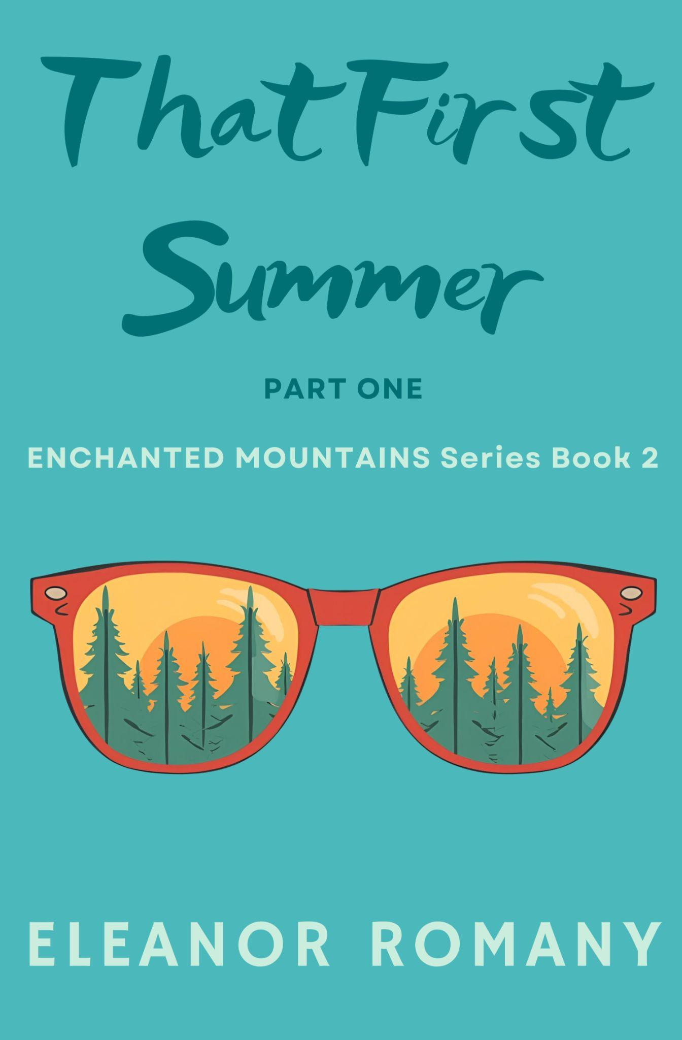
Rating: Amazon 4.2; Goodreads 4.5
Genre: Contemporary romance
Themes: small-town; set in 1990s; summer; nature and outdoors; workplace; teenage crush; no spice
Format: Paperback
ISBN: 9798999679611
Price: $7.99
Page Count: 128
Publisher: Independently Published
Released: March 2026
Book Description:
It’s the summer of 1999, and sixteen-year-old Jonie Kirkland’s job at Twin Pines State Park’s swimming pool feels like a dream.
She finds more than she could have ever hoped for: coworkers who become friends, Brandon Murphy, a goofy boy who tries to win her heart, and a pool run by the quiet and mysterious Alice Livingston.
But just when Jonie finally feels settled, it all comes crashing down. Alice, who has managed the park pool for decades, guarding both its traditions and her own heart, watches Jonie navigate the kind of disappointment she knows all too well.
However, what Jonie sees as the end of something is, for Alice, only the beginning.
Perfect For Readers Who Enjoy:
• 1990s throwback; teenage crushes; 1990s nostalgia; secrets and rumors; cliffhangers
Available Through:
IngramSpark; direct from author
Wholesale Terms via IngramSpark:
• Discount: 40%
• Returns: Yes

Burning Bright (book 3)
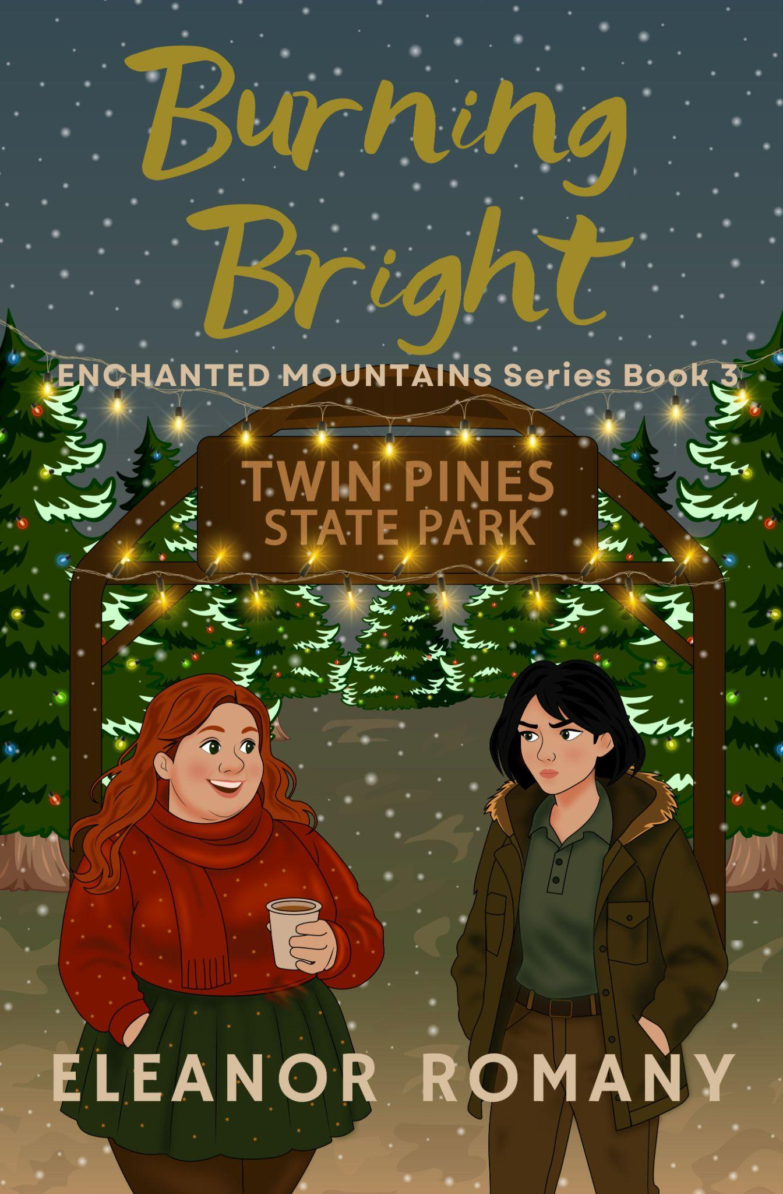
Rating: Amazon 5.0; Goodreads 4.71
Genre: Contemporary romance
Themes: Christmas; small-town; nature and outdoors; workplace; no spice
Format: Paperback
ISBN: 9798999679635
Price: $9.99
Page Count: 195
Publisher: Independently Published
Released: June 2026
Book Description:
Katherine Ellison has spent years avoiding Christmas. As a park ranger at Twin Pines, she prefers animals over people, winter solitude, and anything that doesn’t involve twinkling lights or forced cheer. But this year, to her horror, she’s been put in charge of the park’s biggest event of the season: Christmas in the Pines.
Festive, relentless, and entirely too enthusiastic about everything Katherine avoids, Tessa McIntosh is determined to make the festival the best one ever. As first-year president of the Friends of Twin Pines Volunteer Society, Tessa isn’t letting anyone stand in her way.
When a sudden snowstorm traps them together, the distance between them begins to melt. But as old wounds resurface and the festival draws closer, they both must decide if they’re willing to face the past and risk their hearts.
Perfect For Readers Who Enjoy:
• Grumpy and sunshine; one-sided instant attraction; falling fast; lesbian romance; forced proximity
Will be available through:
IngramSpark; direct from author
Wholesale Terms via IngramSpark:
• Discount: 40%
• Returns: Yes

MATERIALS AVAILABLE UPON REQUEST
- High-resolution cover images
- Author photo
- Signed copies

EVENTS & LOCAL CONNECTION
Local author based in Lexington, Kentucky, available for signings, book club visits, or in-store events across Kentucky and elsewhere.

